ANIMALS & pets

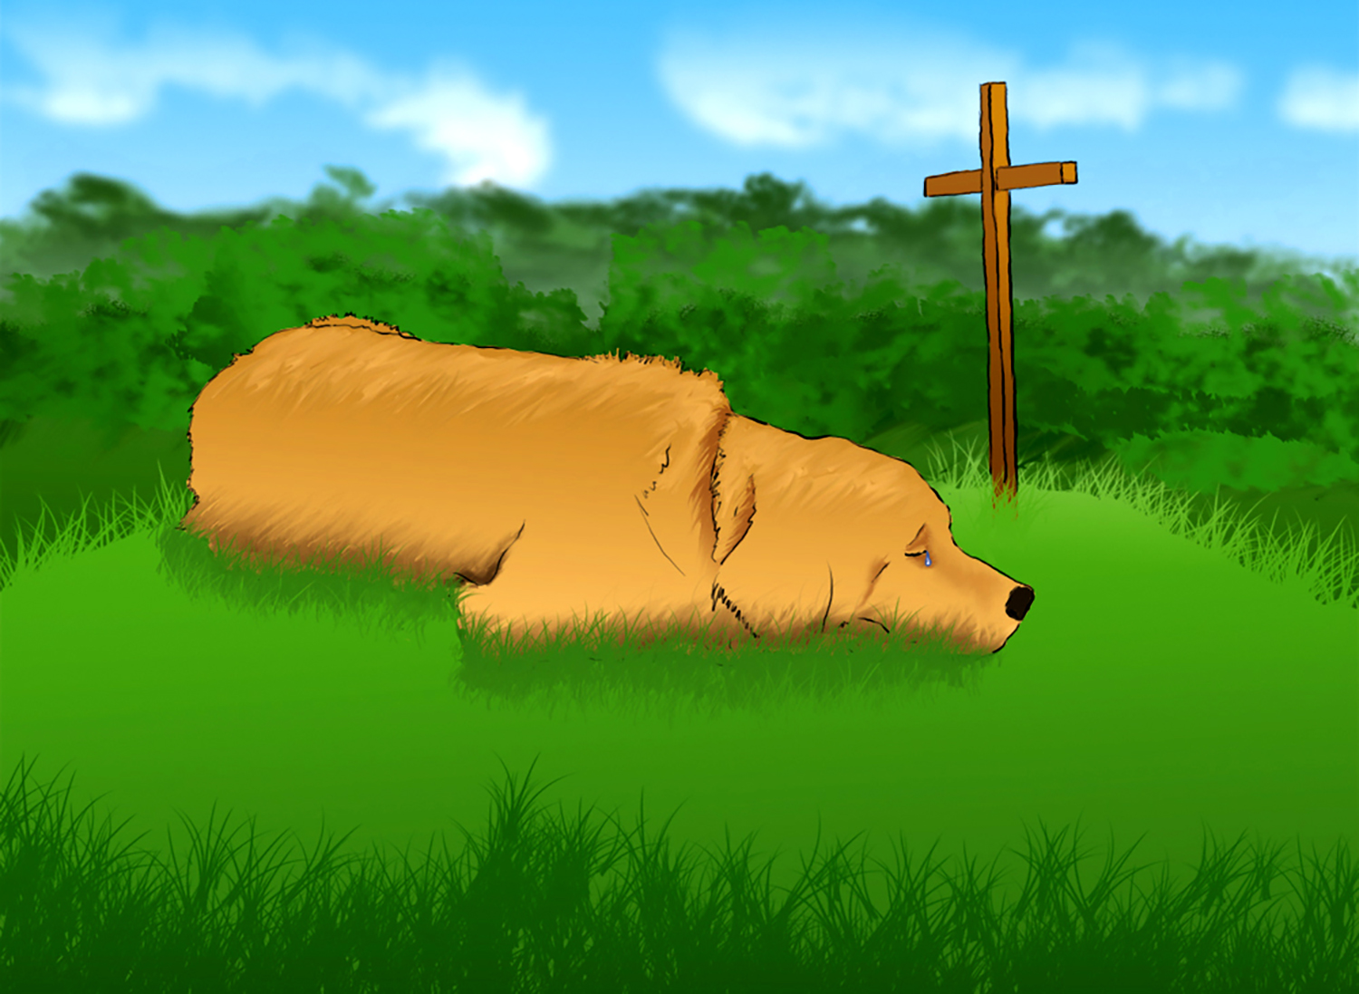
The Legend o’ Big Shawn ‘n’ Buck

As a lad I were tol’ by me fodder ‘bout a man dey were callin’ “Big Shawn,”
An’ da tale were a pitiful sad one, fer it tol’ o’ da t’ing dat ‘e done.

It tol’ ‘bout a day when da mine where ‘e worked… in da cold… an’ da dark… an’ da damp…
Would cost ‘im ‘is life, but what ‘e would do, would save half da men in da camp.

Me fodder said Shawn were a hulk of a man… an’ ‘e went, an’ ‘e done, as ‘e would.
An’ dere weren’t a man ever took him, he said… nor ain’t been a man ever could!

But early one mornin’ - with pick in ‘is ‘and - big Shawn were jus’ workin’ away,
When timbers come loose, an’ dey all went t’ runnin', den… 'ccordin’ to what dey
all say...

Shawn went an’ grabbed ‘im a pillar an’ said, “I’ll ‘old ‘er as long as I can.”
An’ dat were da last ‘e were seen in dis world. Yes… Shawn were a hell of a man!

But ‘ere’s where da story gets sadder. Big Shawn had a dog name o’ Buck.
‘E always was tellin’ ‘is mates o’ da way dat da dog had fer - bringin’ ‘im luck.

Dey say dey were always t’gether. It were Shawn… wit’ ol’ Buck by ‘is side.
An’ t’ most it were not a surprise in da least ‘ow ‘is loyal old dog went an’ died.

‘E made ‘im a bed on da ground just above where Big Shawn ‘ad been buried dat day,
An’ dat’s where ‘e lay… ‘til ‘e withered away.
It’s amazin’… but… dat’s what dey say!

Man’s Best Friend

Can’t believe I used to think - when I was very young - that dogs made poorer pets
than cats and birds!
It wasn’t long before I learned how awesome dogs can be… which changed my mind
and made me eat my words.

Birds are nice to listen to - and cats can be amazing - and I was always pleased with
those we had…
But I have found that neither work as hard to earn your love… especially like the one
that saved my dad!

Katie was a setter, with a shiny copper coat and hazel eyes that took your breath away.
Still a pup the year my father’s tractor lost a tire… which overturned and - there my
father lay.

Pinned beneath the steering wheel, half a mile from home, Dad could barely breathe
and would have died,
But stroking Katie gently… knowing if he hadn’t told her to save his life she'd need
to leave his side,

She’d have never left… he whispered, “Katie, go for help,” then doing as he told her,
off she flew.
Knowing no one else was home, she ran to Harvey Michel’s… the nearest friend of
father’s that she knew.

Katie’s frantic barking made it clear to Mr. Michel that something very terrible was wrong.
Racing to his pickup, Katie knew he’d understood, and as she headed back, he trailed along.

Lying there, unconscious, Dad was very badly hurt, and had his dog been anywhere but there…
And had she not obeyed and found him someone who could help… then quickly led the way to show them where,

Gordon likely would have died, and had he passed away, we never would have known
of Katie’s deed.
Dad would often claim she was the “smartest dog alive,” and every time he did, we all agreed.

Add to that the fact that at a ski resort in Denver, a toddler was abducted by some guy
Who’d told her folks he'd sell her back for fifty thousand dollars, and, if they didn’t pay… he’d let her die!

The family’s German Shepard, with his nostrils to the ground, went racing to a van out
on the lot.
Colorado troopers stormed the van and saved the child, and fifty years was what that bastard got!

I read where, up in Idaho, while camping with his fam’ly, a four year old had wandered
off the site,
And after searching long and hard, but unsuccessfully - and fearing that he’d not survive the night -

State police showed up to help with search dogs - turned them loose - and half an hour later he was found.
Cold and scared, but still OK, another missing child was rescued for its fam’ly - by a hound!

And everyone in Bozeman knows what happened when the Baxters found a big old
grizzly in their yard.
Who raced out to chase him off - from where their kids were playing? Ron and
Peggy’s big old St. Bernard!

And Merle and Hattie Roth ‘ll tell ya’, “dogs are man’s best friend.” At sixty-five, old Merlin had a stroke.
Falling nearly thirty feet while working in their silo…both his back and collarbone were broke!

Merlin’s cocker spaniel saw him fall and had the savvy to race off to the house and fetch his wife.
Busted up the way he was - according to the doctor - the dog, by what he’d done - had saved his life!

Ain’t no doubt about it, dogs are dynamite communicators… really great at letting people know
If and when there’s something wrong, then leading those who’ll help to where it is they need for them to go.

Cats, of course, can often make magnificent companions, and birds are nice to look at,
and to hear… But next to dogs -- like those I’ve mentioned -- far as I’m concerned… cockatoos and tabbies can’t compare.

Territorializing

Slithering slowly, so very precise,
A methodic invader (and catcher of mice),

He stealthily slips toward the “enemy” there,
So unsuspecting, at rest by the chair.

Without a diversion to aid his approach,
And only his instincts, I watch him encroach.

So lethal and cunning, the hair on his back
Stands rigid… it bristles before the attack.

His innocent victim still lies unaware,
No clue he is fixed in the merciless glare

Of the eyes of a killer. With talons now bare,
His heartless attacker now springs through the air,

And, sinking his claws in the neck of his prey,
He arches his back and then hisses to say,

“No stupid dogs are allowed in this room.
Try this again and you’ll know the same doom!”

And off the dog whimpers, like you’ve never seen…
And I have to tell you… that kitten is mean!

On Caging Birds

I walked into a pet shop on a rainy afternoon and spotted - on a sign - the following words:
“Dogs and cats of every breed on sale through Monday night. We also carry turtles,
fish, and birds,

Gerbils - mice and rats - iguanas - lizards - baby crocs… plus butterflies and snakes of every kind.”
Right away I started down an aisle of tiny cages… enthused about the types of pets I’d find.

One side of the aisle was lined with pens of metal mesh that held their line of rodents - with their “wheels.”
I pondered as I watched a tiny gerbil twirl his runner… ‘I wonder how that little fella feels.’

The other side - a wall of three-by-three-by-three compartments - was nothing more
than windows - on a box.
Many held a pair of puppies… others three or four… and one - down near the end -
an arctic fox!

Most of them were sleeping, but a few were scratching wildly, seemingly to dig away
the glass.
Some that were awake were actually lunging at their windows, and barked, or started whining, as I’d pass.

I can handle showing off the puppies like they do… most of them are one to two months old.
I know they’re clean and healthy, as they wrestle with their cellmates, and that it won’t be long before they’re sold,

Then, just around the corner, hung a neon sign that read: “Directly from the Nicaraguan coast.”
Below the sign the cage was thick with birds, and I must say… that was what disgusted me the most.

Parakeets - canaries - toucans - parrots… even ravens - from ones that talked to those
that only peep.
And as I stood there staring, as they flitted back and forth, my heart would break, and
I began to weep.

I don’t know how anyone can actually take a creature that's born with wings - with
which they’re meant to fly -
And lock it up inside a cage to never get the chance! I’m not ashamed to say… it made me cry.

Yes, I know… around the globe… the market’s huge for pets… but I was not prepared
for what I’d see.
I can understand the way the others are displayed, but as for caging birds… it’s not for me!

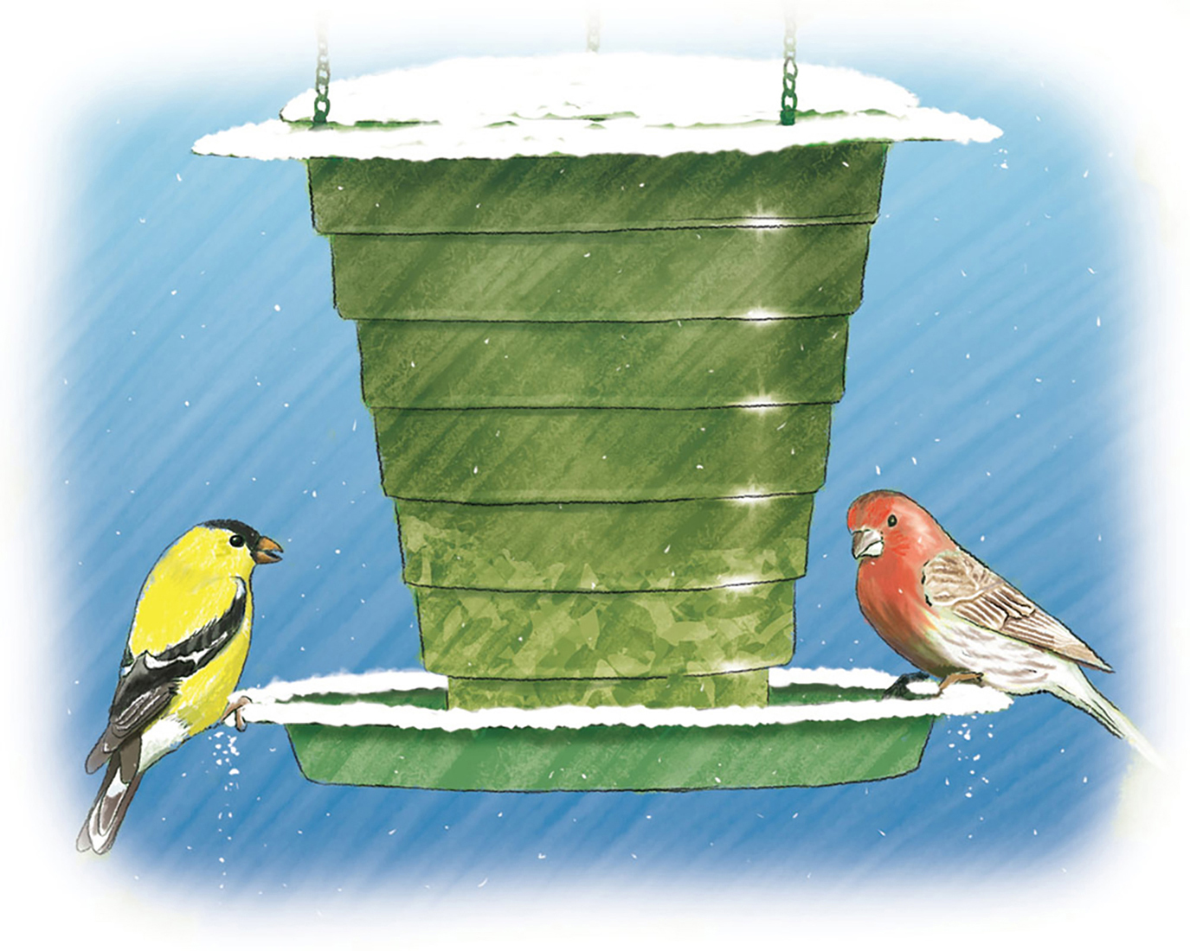
The Feeder

One brisk winter morning, as I sat and tried to write, while snow was falling gently on our lawn,
I noticed that the seed - inside the feeder just outside the window where I often sit - was gone.

It wasn’t long before a hungry sparrow hovered near and then, for but a moment, came to rest
Upon the feeder’s lip, and carefully scanned the empty tray for what would make a meal, back at her nest.

I started feeling guilty, as I watched the tiny bird expectantly inspect the tray for food.
Speculating she was one of many desperate moms in search of tiny morsels for her brood,

“Honey,” I would holler out, “I see the feeder’s empty. I guess we’ll have to make a run
to town.”
“Yes, I know,” she answered back, “it’s been that way a while, and I would really hate to take it down,

But with the bills the way they are, I’m really sad to say… there are no extra funds to pay for seed.
I’ve been throwing little bits of bread and older crackers to help provide the nourishment they need.”

“Oh, come on, dear,” I argued, “in the summertime that’s fine, but when the snow has covered up the ground,
Food becomes more scarce, of course, and feeders then become the one consistent place their meals are found.

“I’m for buying seed no matter what, and dear, what’s more… I’d like to hang another feeder, too!
I’ll give up my ice cream… and I’ll ride my bike to work, so we can pay for both. It’s up
to you.”

“Fine with me,” she smiled and said, “I love the way you think. To me the birds are… flying works of art. I will always want them near… and spring will bring us more… and we’ll be glad we did our little part.”

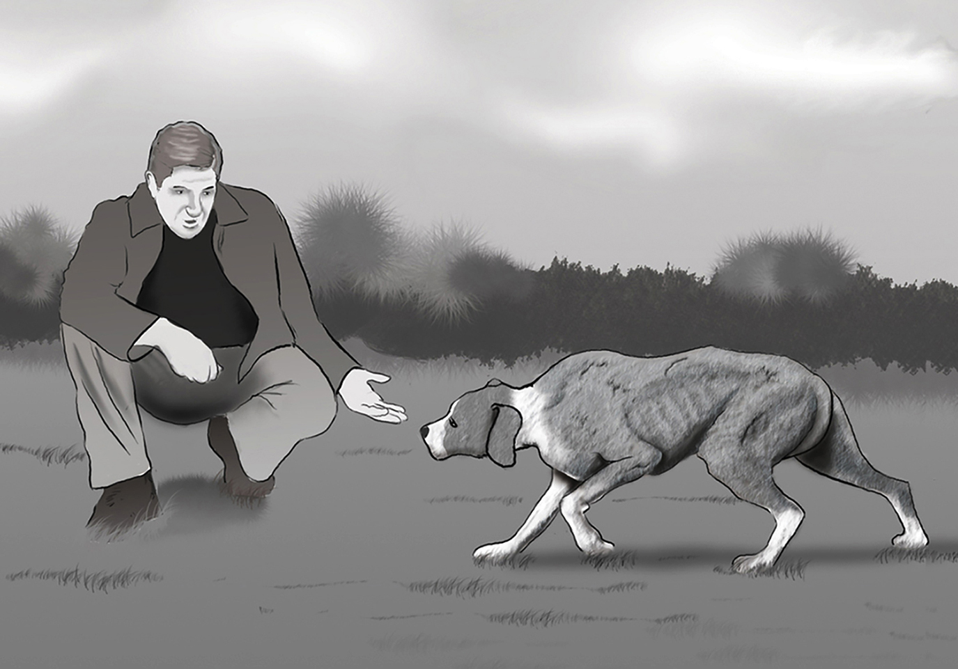
What a powerful bond often develops between dogs and those that call them theirs…

Duke

Bony-thin, and limping, when I spotted him that day, his ears were down… his tail, between his legs… his courage, gone.
I knew that he’d been beaten, and it almost broke my heart to see him work so hard to make his way across the lawn.

At first I thought a car had hit the trembling mongrel dog. He whimpered softly,
veered away, and tried his best to run.
He saw me watching closely as he paused to choose his way, knowing there were
those who felt - his type deserved the gun.

Terrified and unaware I sympathized with him, the only thing he knew was… he’d been beaten half to death.
I trotted out to steal his way by standing in his route. He fell before my feet to draw -
he thought - his final breath.

Convinced his life was over, he was quivering very hard. I crouched to stroke his bleeding head and whispered, “It’s all right.
No one’s going to hurt you, boy. Don’t worry… it’s OK.” And said a little prayer that deep inside he had the fight

To hold on just a little longer… just a breath or two. I knew that I could save him, but
I saw no will to live.
His eyes were glazing over, as I took him in my arms, and I began to tell him of the help
I planned to give.

“First you’ll get the biggest steak that you have ever seen. And then you’ll get a bath, and you can sleep beside my bed.
I will dress your wounds, and you will be as good as new.” Fin'ly understanding he was safe, he raised his head,

And I would feel his gentle tongue caress my helping hand. He knew that he could trust me…and his will would be restored.
And I would give him everything I’d promised from the first. I showered him with all the love and help I could afford.

That is how I met old “Duke,” a mongrel through and through. Don’t know where he came from… but he’s been here ever since.
He’s never seen a chain, and he has always slept inside. He’s eaten what I eat myself…
and never known a fence.

This, for me, explains why, when the furnace caught on fire a year ago last August,
and the house had filled with smoke,
And I was rendered helpless by asphyxiating fumes, Duke would sense the danger, and…because he heard me choke…

Run to where I lay, almost unconscious… close to death… and use his every strength to
drag me slowly to the door! Duke returned the favor when he saved my life that day… and there’s no way on earth
that I could ever love him more.

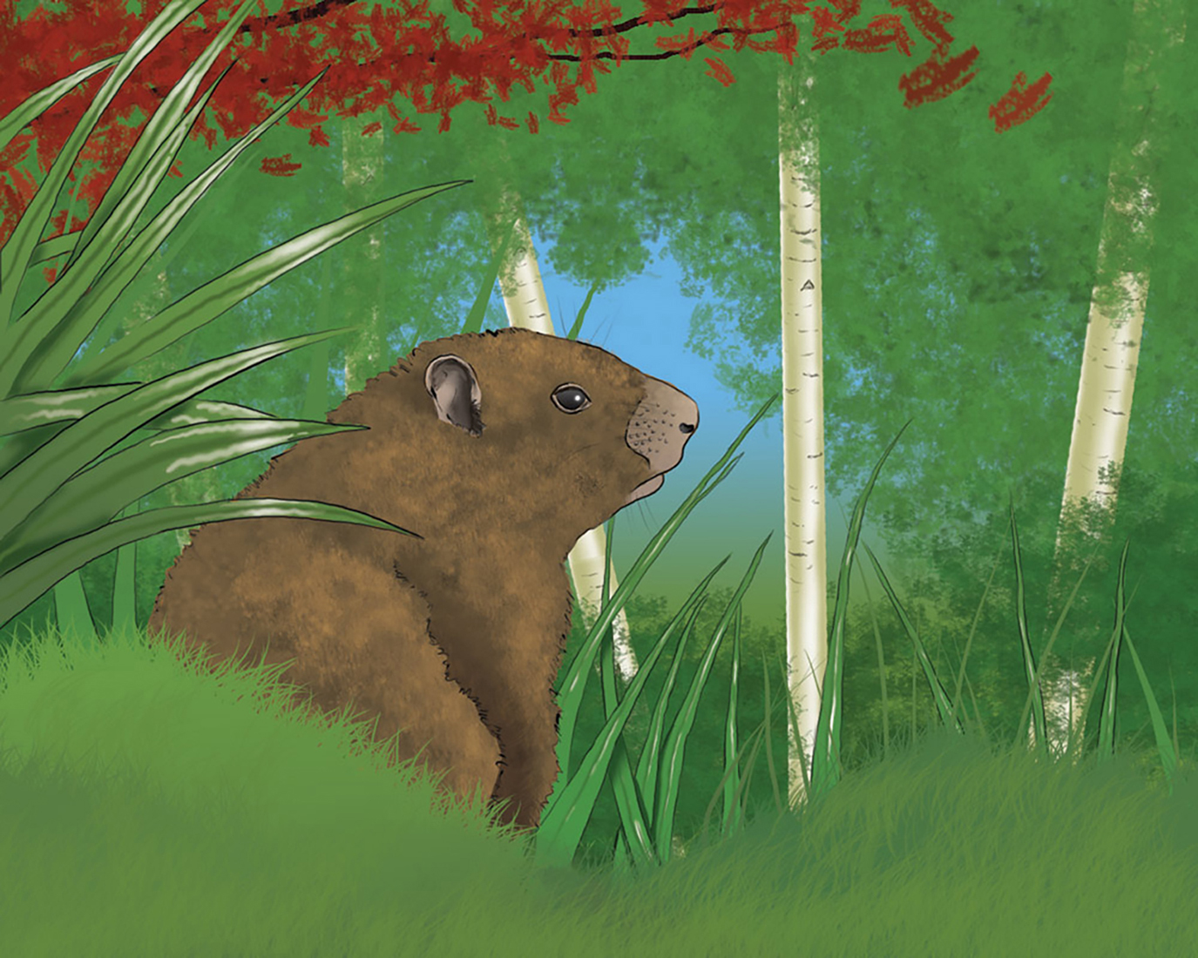
Joe

He never seemed uneasy when he’d spot us at the window, but checking intermittently, he’d watch us like a hawk.
It puzzled us to contemplate how anything so chubby - so unprepared for danger, and
with such an awkward walk -

Could live so long and look so well. And when he tried to run, we couldn’t help but feel concerned to see him move so slow.
And almost every morning… as the sun was coming up… we’d try to make the time to check the whereabouts of “Joe”.

The first time that I saw him was about five years ago, and I’m not sure exactly when we named him Joe, or why.
While standing at the picture window, staring at the woods, this tiny, bushy waddler caught the corner of my eye.

“Look at that,” I whispered softly - worried he would hear - “a little baby groundhog’s
out there… basking in the sun.”
I remember clearly wondering where his folks could be, and - seeing that he looked defenseless - hoping he could run.

Joe was not a real big fan of cloudy days but knew on sunny ones the morning rays would flood our tiny lawn.
We really loved to watch him take advantage of the freshness… wallowing in the beauty and tranquility of “dawn”.

As the years went by we found the strong, consistent nature of early morning creatures, like ourselves, would meld a bond,
And taking peeks to see if Joe was waddling through the sunshine soon became a ritual of which we were truly fond.

Sometimes only Connie saw him… sometimes only me, but both of us would let the other know when he was there.
And I remember several days when he was strangely absent - despite the perfect weather, and it gave us quite a scare.

As he grew, he only waddled harder, and I swear… even in my sixties I’d have easily chased him down.
How he’d made it through the years, surviving in the woods we built our little cabin in, about a mile from town,

Always has amazed us ‘cause we’ve often spotted coyotes and wild dogs that - as you know - will hunt from dusk ‘til dawn. Naturally, our anxiousness grows harder to ignore as we prepare to one day learn - our Joe, at last… is gone!
It’s been about a month now since we’ve seen our old companion. It snowed last week,
so we prefer to think he’s - gone to bed... And the other groundhogs that we’ve seen are simply - running late… and spring will bring him back to us. He simply can’t be dead!

The Misunderstanding

Sitting in a restaurant, one early Wednesday morning, I overheard a couple guys discussing favorite things
They’d done in their careers concerning shooting wild game, replete with little quips
about the pride it always brings.

“Sneaking near was quite a trick, but I got close enough to actually see the color of his eyes,” I heard one boast.
I tried to find some clever way to drown their conversation, but all I’d got was coffee…(how I wished I’d ordered toast.)

“Like shooting fish inside a barrel,” and, “never saw it coming,” “the easiest shot I ever got,” and, “what a thrill it was,”
Joined the callous comments, and - what hadn’t made me sad back when I was younger,
I would realize… now does!

As a youth I’d downed my share of pheasants, ducks, and geese, and one day, with my Uncle Ed, I even killed a deer.
But I’ve not held a rifle or a shotgun in my hands to hunt for game in close to thirty years, and now to hear

People proudly gloating on the way they’d “made the shot” had me… more than ever…thinking poorly of myself.
Today, I feel that birds are truly flying works of art, and look a whole lot better in the sky than on a shelf.

Some will claim, in spots, the population of the deer gives cause to thin them down a bit, and granted… that might be,
But I’m now so enchanted by their presence in this world… the one who volunteers to take their lives will not be me!

The sight of deer out grazing in the woods, or in a field, evokes an aching memory where
I clearly watch one fall -
Then proudly pose for pictures of me holding up its head - then saw it off, to take it home, and hang it on my wall!

Only minutes later, in response to mixed emotions, and in a terse and pithy tone that typically offends,
I sneered, “I’ll bet you always use your very biggest guns!
Then one replied... “Why, no… we use a telephoto lens!”

The men were both photographers… and I’d misunderstood. I felt so very stupid,
and I turned a little red.
“Sorry, fellas,” I explained, “I thought you guys were hunters.”
“I think that’s rather obvious,” the same young fella said.

“But we know where you’re coming from,” the other guy would add, “we photograph the wildlife of the world, and always will. We only wish that there were more who thought like you and us, and chose to shoot - with cameras - what so many rush to kill.”

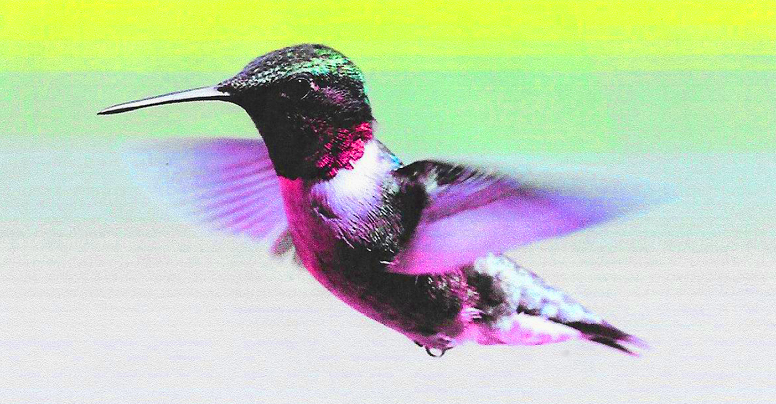
The Hummingbird

The first time that I saw one I could not believe my eyes. It seemed a wingless body…somehow floating in the air…
With tiny head… a slender beak… a stubby, twitching tail… and flanked on either
shoulder by an iridescent flare.

Its colors were amazing, like I’d never seen before, with yellow speckles, silver tufts,
and brilliant ruby throat.
Like ailerons made of feathers - what I learned to be its wings - hummed with focused frenzy, as they kept the bird afloat.

His hovering seemed so effortless, so agile, and so graceful. His wings were imperceptible but for the sound I heard.
I softly whispered, “Grandma, what’s that funny little thing?” She whispered, “It’s your lucky day… you’ve seen a hummingbird!”

Mesmerized, I watched him, as he darted ‘round the gardens, sampling from the blossoms that adorned her lovely lawn, Pausing only briefly for the nectar in each flower, until at last… as quickly as he’d come… the bird was gone!

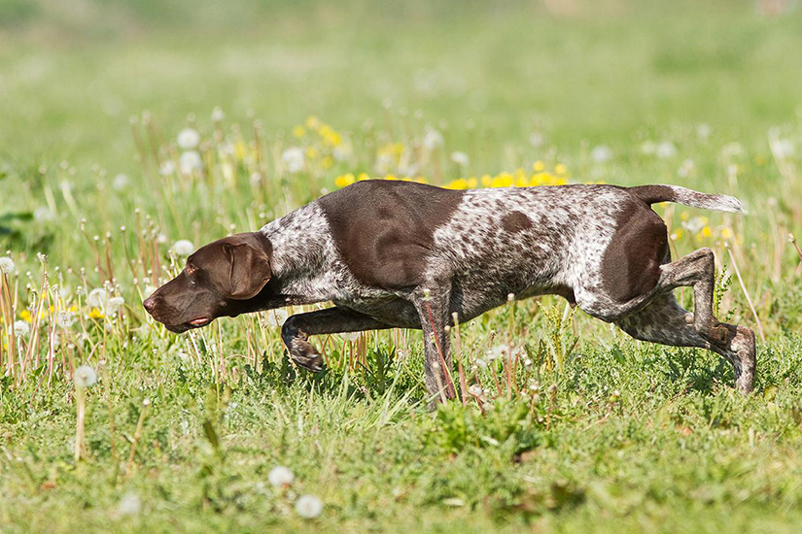
Freckles Made an Excellent Point, but then... So Have I

Our German Shorthaired Pointer had, for years, retained the trophy
awarded for the flushing out of furred and feathered game.
Thought to be the best of breeds for rousting hiding prey,
he'd proved this true repeatedly, and 'Freckles' was his name.

My dad was pushin' fifty when he brought the youngster home,
and he an' I'd spent several hours refining Freckles' skills.
At 2 years old - in less than 7 weeks - he'd fully mastered
the pinning down of well-concealeds and fetching back Dad's kills.

Being an avid hunter, when the fowls were fairly plentiful,
he'd usually reach his limits-worth within an hour or two,
And with a fine retriever like our Freckles there to help,
dropping fifteen pheasants wasn't all that hard to do.

The point I'm tryin' to make with this is - as a boy of seven -
being allowed to join the hunt - for me a thrilling first -
And given a 4-10 single-shot to do what I considered
the most unnerving chore in which I'd ever been immersed,

I was prob'ly more surprised than Dad with my response -
and couldn't believe my ears when I reacted like I did!
"That's a darn big shotgun, Dad," I actually stunned us both...
"pretty hard to handle for a seven year old kid!

"And I ain't got a license," I continued, "don't forget, sooooo -
You can down 'em... Freckles 'll fetch 'em... an' I'll just bag 'em up!"
I'd long been quite concerned about the day I'd be expected
to drop my first bird ever since when Freckles was a pup!

Something deep inside me'd told me time and time again
that killing helpless prey that do - if any - little harm
To simply stuff - or eat them was a practice I disfavored,
and every time we'd visit Granddad Virgil's nearby farm

To bag my father's quota of what I considered - 'artwork',
painted on an azure canvas - dabbed with cotton fluff,
Just to prove ones prowess as a hunter and retain
his 'best retriever" trophy was, in my eyes - not enough!

This explains, to me at least, why - every year since then,
invited once again to hunt for pheasants with the guys,
As they were expecting, I'd contrive some made up 'why'
for passing on their offer - and has made them realize

That I perceive their penchant for the killing of His birds -
gifted us to marvel at for seeing them in flight -
And opting for a preference where the skies are less-adorned,
as something I believe, and always will think isn't right!

As Was Only Right, I Turned My Captive Loose

"You ain't gonna kill 'im, are ya'," someone from the crowd spouted out defiantly... "just
turn 'im loose somewhere."
"They're nowhere near as plentiful as back when you were born," a second watcher reasoned, "and, for one, son... I don't care

"If some old scraggly cougar's out there runnn' 'round the hills! Truth be told ya' hardly ever see 'em anymore!
They're only tryin' to stay alive... and don't forget, young man... it wasn't us who showed up first... they were here before!

"They say - with how they're clearin' trees - they're bound to go extinct, and the cost o' that - to me, at least - despite the toll they take -
Even killin' cattle - ain't worth nowhere near the price... and definitely not a bargain, son,
that I'm prepared to make!"

The gal who'd thrown the first complaint had slipped from out the herd - the herd o' folks who'd gathered when the rumor'd reached their ears -
When, "Let him go," some fella barked... "they're gettn' awful scarce... hell... I ain't seen a cougar in the flesh for thirty years!"

I was pushin' twenty... she an' he were gray as hell... and all the rest were pushin', or were over, forty-five.
"Just might be," he added, "if the cougar is endangered... this one here - on down the road, could be the last alive!"

I'd snagged 'im high on an upper slope, usin' a homemade snare, then drugged 'im up an' run 'im down to the Buckin' Horse Saloon.
I asked a couple good-ol'-boys to help me spread the word that - 'every rancher wantin' in on a special treat - aroun' noon -

'Could win a chance to take a shot - literally - 'take a shot' - at one of what was known for leavin' grazin' cattle dead!'
I meant to 'round up several ranchers - show them what I'd caught - then auction off a chance to put a bullet in its head!

I'd shoved him into a large steel cage - (before the drug wore off)... then chained the cage to a flatbed trailer - prime for an anxious crowd -
But as the ones who'd gathered stood there - none of whom were ranchers - puzzled by the fact that I was somehow seeming proud,

I could tell, by 1 p.m., that no one else was coming'! I knew, when those who'd spread the word had let the ranchers know
What it was the winning bidder'd get was going to be a chance to kill a cougar - one they felt should be let go -

And actually take its life while it was trapped inside a cage --- all were obviously passing! There was no one but these few
Who'd overheard me advertisin' what it was I'd done... and listened to me tellin' what it was I planned to do!

Havin' had three members of the crowd denounce my plan - ones who'd made it crystal clear they'd vote to turn it loose -
And, havin' had no takers for my auction, it was time to pull my brainless pin-head out and put my mouth to use.

"Listen guys," I started out, "I've fin'ly seen the light. I'm headin' out this afternoon to pick up all my snares.
I won't be trappin' anything but mice from this day on... not mountain lions... timber wolves... or even Grizzly bears!

Instead of usin' bullets I'll use only anesthetics whenever they're discovered where they're not supposed to be,
An' far as what I plan do with this old timer here... I'll run 'im up a couple thousand feet an' --- set him free!

How We Wound Up With a Rescue Dog

“Let’s pop in to the rescue shelter, hon,” my wife proposed, “it’s been there now, as I recall, for close to seven months,
And I got scolded pretty good by you-know-who last week when I confessed neither of
us have stopped there even once.

“She’s big on rehabilitating slightly injured animals, and has a heart the size of Texas when it comes to dogs -
And...like she says… ‘It ain’t like those who’re being abused or starving show up in
the want ads - or in Sear’s catalogs!’

“The dachshund that I had when I was young was really sweet, and you bring up your fam’ly’s Cocker Spaniel all the time.
They make a great companion, as you know, for older folks - and neither you nor I, by any stretch, are in our prime.

“Whadaya say,” she stayed on point, “both of us love dogs... it’s only about a mile away, and we’ve got time to kill?”
“Not a bad idea,” I quipped, “it’s true - we both love dogs - and if we spot a project that we’d like to buy, we will!

“More than half our neighbors have a dog - a few have two - and every time I see one strolling past it tweaks my mind,
So, I’m with you, dear... popping in to look around can’t hurt, and - like you say - we’ve plenty o' time... and who knows what we’ll find?”

Thirty minutes later we were filling out the paper work to buy ourselves the weakest St. Bernard we’d ever seen,
And, to this day, we can’t believe how any human being with any brains - or heart - at all can be so cruel - so mean!

Roughly three years old, she could have passed for barely one! Her spine and ribs on full display, from seldom being fed,
The owner of the shelter claimed that... had she not been taken... based upon her vital signs she’d ‘ve very soon been dead!

They’d rescued her from an old X-con whose neighbor'd turned him in for locking her in
a tiny cage whenever he’d leave town,
With no arrangements whatsoever made for what she’d need, and often threatening - when she’d whine for food, to - 'put her down'!

Warned that - if he caught him on his land, or if his camera offered him the proof he’d need - he’d whined up being sued…
The guy who’d turned him in had been afraid to make the call! But after several failed attempts to somehow get her food,

He found, at last, the courage to report the starving dog. The shelter doesn’t tell the ones they take their projects from
Whom it was that turned them in for how they treat their victims, and even though too often it’s 'the end of the line' for some…

That deprived and barely-breathing, long-neglected dog wound up going home with US,
and... as you’ve guessed by now…
After thirty days of love we're very proud to say... if Brandy’s legs were longer... you’d mistake her for a COW!

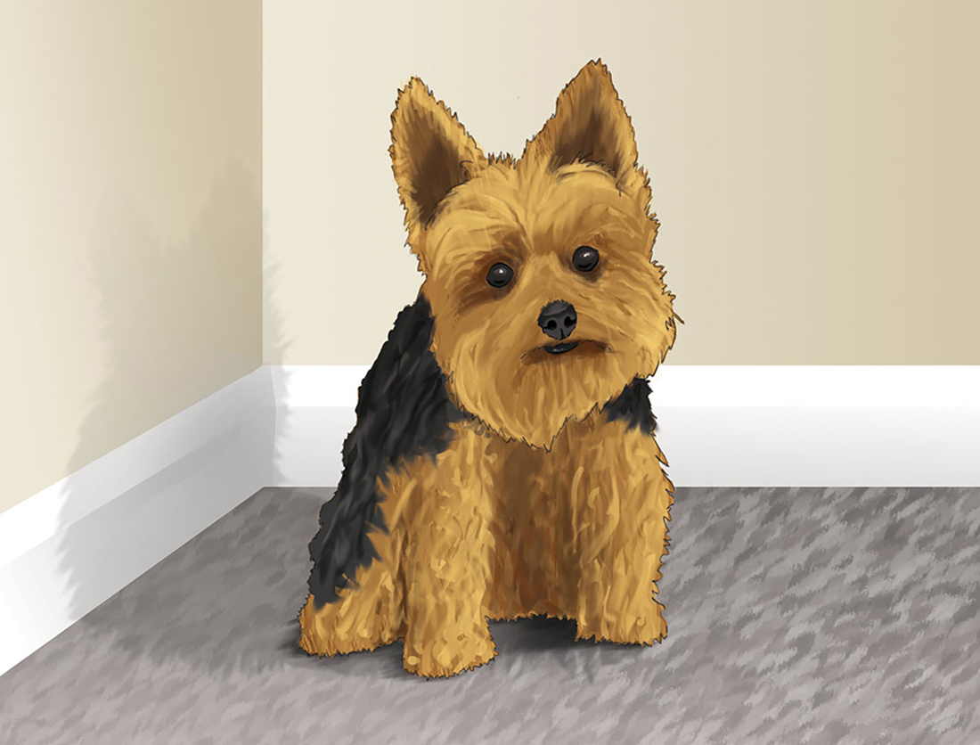
The Orphan

While strolling past the window of a small department store,
I spotted something I was not exactly looking for.

The object of an almost never-ending small dispute,
And I’d have simply walked away, had he not been so cute.

“See Our Pet Department” was the way the small sign read.
I thought about my husband, Roy, and what he’d always said.

“I would love to get a dog, but, honey, we agreed,
Right now we really can’t afford another mouth to feed.”

I stood and smiled to watch the little puppy with its bone.
He looked so soft and cuddly, as he lay there all alone.

I told myself it couldn’t hurt to ask how much he was.
I always watched for special deals… as every good wife does.

To my surprise the clerk said, “He’s an orphan… but he’s nice.
We had to bottle feed him… and he’s small… so he’s - half-price.”

I liked the fact that he was tiny… knew the price was good…
And asked myself, “Would Roy agree?” Then told myself, “He would!”

And so this little orphan left his cage to start a life
With collar… leash… a well-chewed bone… and very nervous wife!

I wasn’t home for very long when Roy rolled in the drive.
I wondered if he’d wind up pleased - or skinning me alive.

I asked him how his day had gone, and what he’d like to eat,
Then handed him the paper, sat him down, and rubbed his feet.

I guess I overdid it when I said, “I love you, hon.”
He slowly dropped the paper and asked, “Dear… what have you done?”

“You know how much you’ve always hated throwing scraps away.
Well… I have always felt the same, and so… while out today…

“I found the perfect answer, and now, honey… just relax,
And promise me you won’t get mad - ’cause - once you know the facts,

“I’m sure you’ll be OK with this. I know you will agree.
I found the cutest thing today. A friend… for you and me.”

The frown upon his face would tell me things weren’t looking good.
I told him if he thought that I should “take him back”… I would.

But when I walked him back to where the sleeping puppy lay,
I heard a few of the sweetest words that Roy would ever say.

“I love you, dear, and promise you, my love will never end,
And I am tickled pink that you have found us both a friend.”

I cried a little, now and then, for several happy days
As the puppy kept reminding me of Roy’s endearing ways.

The dog would stay, and as time passed, we rarely were apart.
He quickly found his way into the reaches of my heart.

I taught him all the standard tricks…
roll over…
sit…
play dead.
He hates it when I brush his hair. He makes me scratch his head.

And he will do most anything to wriggle close to me.
And as the years rolled by I came to very clearly see,

It wasn’t only he who needed me… I needed him,
For when… through many nights, my crying eyes with tears were dim

As I would weep in sorrow, for my Roy… who now is gone…
He was - again - the dearest friend I’ve always counted on.

And you know what... the reason why it all worked out so nice,
Is I brought home an orphan… that I actually got - half-price!

The Worst of Them Are These

Sittin' alone on a cloudy day, an unfamiliar melody wafting through the morning on a cool yet sultry breeze,
Pond'ring quietly what, for years, have been my saddest mem'ries... I would come to realize the worst of them are these:

Strolling through a zoo one day, I passed a concrete habitat advertising - "TIGERS - DO NOT ENTER - DO NOT FEED".
Lying on the pavement - while abducted from a grassland 50,000 acres strong, the size that tigers need,

On his face, his gorgeous face, a look of great despair seemed to be imploring me: 'Is this to be my home?
Was I not endowed with lands our Dieties ordained... worlds where we - and what we're known to hunt - are known to roam?'

The length of his enclosure was but 50 feet at most... the filthy cage in which he slept, I figured 10 by 10 -
Bringing me to tears to see him trapped inside a realm a couple hundred million times as small as where he'd been!

Another awful mem'ry that I'm struggling to forget is seeing a dog, a friendly dog, for, often, several days,
Pacing back and forth inside a tiny outdoor cage as the little turd who'd begged to get one nonchalantly plays!

The sight of 10 or 20 fish circling 'round their dungeon... ever trav'ling days on end within their 3 foot home
Also drives me up the wall! They're better off in ponds, rivers, lakes and oceans than the prison that they roam.

And watching someone's hamster spin its wheel in lieu of 'freedom'... far - in my opinion, from a truly fair exchange...
Only serves to emphasize the cruelty of their owners, satisfied to pen them on a 3-by-3 foot 'range'!

And last, but nowhere near the least, what truly burns my butt... what actually, when it happens, fills my mind with utter rage...
Is bumping into some damn fool who thinks it's 'no big deal' to lock a creature - fit with wings -- inside a flippin' cage!

Whenever Convictions Are Strong

“Less than impressive,” my listener replied, when I asked his opinion one day.
“Nothing I’d bother to post on the web, or to publish,” he went on to say.

But what I’d just read was a poem my daughter had written when seven years old,
And... given he’d no way of knowing the factors surrounding the story it told...

I understood his reaction, of course, ‘cause what she was meaning to say
Was typically something a child her age would struggle to clearly convey.

To him what she’d penned --- a cute little piece that a kid of just seven would write -
Who knew - it’s the size of the fight in the dog --- not the size of the dog in the fight -

Was actually a boast on the guts that it took for her Yorkie... of barely three pounds...
To gamble its life to protect whom she loved from assault by much heftier hounds ---

Was merely a youngster espousing her puppy’s devotion to save her from harm...
A canine the size of a baby raccoon that she’d carry around on her arm!

But for knowing that Yorkies, because of their size, aren’t known for the people they save,
And puzzled by hearing her claim that her puppy was - ‘fiercely defensive’ and ‘brave’...

My listener had simply dismissed what her poem had tried to assert as -- “deceiving”,
Assuming their love for each other the reason explaining her actually believing

That - when a young Doberman quickly retreated in fear - from my daughter’s caress -
The flashing of fangs that her puppy’d displayed - to fend off her loved ones duress -

Was proof beyond doubt that, regardless of size... whenever convictions are strong...
No confrontation is more than it’s worth… no battle too hard or too long.

Madelyne’s dog was as brave as a lion - while barely the size of a squirrel,
And knowing that cute little bundle of fur had defended my sweet little girl,

I was OK with the fact that my listener’s - ‘interpretation’ - was wrong,
‘Cause risks are worth taking - regardless the cost - whenever convictions are strong!

How Margie Got Her 'Benji'

"You're right," I told the couple who'd dropped in to buy a 'friend' to entertain their daughter, who had just turned 5 years old,
"Tiny ones like that one there can pass for newly-borns... and runts - in puppies - tend to be among the first ones sold.

"They don't require a lot of food, they're quickly potty-trained... they're really good at learning tricks - they're playful - and they're smart,
And seldom does a stronger bond exist than that between a child and dog it raises... once they've won each others' heart."

"Our daughter has a favorite film," the mother would explain," about a dog she's made
it clear she'd very much prefer,
And being it's meant to be her friend - regardless of its price - whatever we decide to buy, it must appeal to her."

"So... what breed are you looking for," I curiously implored, "if I don't have the sort you need I'll find someone who does."
The father quickly filled me in, "Her favorite film is 'Benji', but we're not all that sure about the breed he actually was."

"I hate to disappoint you," I reluctantly replied, "but when they made those 'Benji' films they always used... mixed-breeds,
Which actually makes it easy to come up with what you want - it's looking like a look-alike is all your daughter needs."

"That's correct," the couple chimed, "and something that could pass for one of Benji's siblings would quite likely do the trick."
"I've got some mixed-breed rescue dogs... one's the Benji type... an' five 'll get ya' ten," I chirped, "he'll be the one you'll pick.

"There's one back there that's still a pup who'd pass for Benji's clone, and, having had the shots he needed, could be sold today.
I'll let you take him home with you to see what Margie thinks, and give the two a couple weeks to horse around and play.

"Once they've spent some time together all of you will know if indeed they match up well and - what you'd like to do.
Margie 'll need to really love him, as I'm sure she will, but you - who'll be attending to his needs, must love him too."

Running the gamut fairly fast, learning cage by cage that most were either far too large, too hyper, or too old,
The happy couple chose the one I knew they prob'ly would, and the tiny - very grateful- little look-alike was sold!

They passed on taking trial time to check their child's response, but each of us is tickled pink with how this story ends -
The small and rather straggly dog was just what Margie'd wanted, and... as we'd all been hoping... they've become the best of friends.

What a Wonderful Coincidence

The one and only dog I've ever seen that by some miracle - having obviously been through hell - lay there, in a cage,
Staring at me... terrified... pleading with his eyes for someone walking past to see he'd fin'ly reached the stage

Where any decent person would assume his life was run, and intervene as needed to assist with his demise.
Problem was... I'd also noticed remnants of a warrior very faintly smold'ring from within his weary eyes!

Tough to figure how a breed this relatively popular could 've fallen prey to what had put him where he was -
Disregarding why he lay there - very close to death - I created time (like any caring person does),

Calling in to where I worked to tell them I'd be late! Risking being fired for having left them - undermanned...
Figuring when I told him that I'd bought a 'rescue dog' - Mr. Gates (who loved dogs too),
would surely understand.

"A Shepherd," I replied when Gordon asked me what he was. "All cleaned up and brushed he'll be a beauty," I went on.
"Any special markings," he inquired?" "If there are... mangy as he is right now, all evidence is gone!"

"Once I've got him washed and groomed I'll text you out a photo. He's pretty big but definitely needs a bunch o' hefty meals.
They said they found him yesterday, abandoned - left for dead... but I can guarantee you, sir... once this dog has healed...

"Once he's lookin' good as new he's gonna be a knockout! The only thing I've noticed is he's got an older scar
Just across the left side of his nose... aside from that, he's pretty much the same as German Shepherds always are.

"Rusty -- that's the name I gave him's - gonna be a stud... and if I had to guess, I'd say he's somewhere close to ten.
But I don't care how old he is... I couldn't bear to leave him lying in that way-too-tiny cage they'd put him in!

"I'd only stopped to ask if I could get an interview to help me with an article I'm writing for the 'Sun'!
I'll have to sneak him in to where I live --- 'NO PETS ALLOWED' --- and never dreamed, before I left, I'd wind up buying one!"

"Where'd you say the scar was," Gordon asked... "precisely where?" "Left side of his nose," I answered... "just below the eye."
"And somewhere close to ten you say?" "Yes," I quipped, "at least"... and given how he looks I can't believe he didn't die!"

"Do me a little favor, Mark -- almost every owner trains their puppy, as you know, to 'sit' - to 'shake' - and 'stay'!
Tell him fairly firmly, son, to 'sit'... and... if he does, also fairly firmly tell him 'stay' --
then -- walk away!

"Making sure he hasn't budged, turn your face away, and watch to see what happens when you call out names like these:
Ones that people use for German Shepherds all the time, like -- Duke an' Rocky -- Thor an' Samson -- Max and Hercules!

"If he hasn't budged despite the many names you've tried... peeking back discreetly, watch his tail and offer --- Zeus!
One thing dogs do not forget, regardless how they're treated... one thing they'll respond to even after great abuse...

"Is, of course, the name that they were given as a pup... back when those who raised them were protecting them from harm.
Here is why I'm asking, son. A couple months ago, our German Shepherd disappeared, went missing from our farm,

"Who, coincidentally - from brawling with a badger - has a fairly big 'reminder' on the left side of his nose...
And I can't help but wonder if the dog that you just bought - might just be the one with whom that badger came to blows!

"So... if, by chance, he comes to you the moment you say - 'Zeus' - waggin' his tail like crazy, Mark - you've got to let me know.
I'll gladly come and get him, and I'll double what you paid! Happy, loving dogs like Zeus do not just -- up-an'-go."

"It wouldn't be hard to coax a dog as friendly as he is into someone's vehicle, then - at some point in time -
Sell him as -- 'an orphan that has suddenly lost its home' -- leaving dog and owner both as victims of the crime!"

"I'll try what you've suggested, sir, then let you know what happened. I actually hope, for your sake, he's the one you hope it is!"
Then... later on that afternoon I phoned my boss to say that I'd found out, without a doubt, what name, in fact, was his!

"Doing as you told me, sir, I offered all those names, and all he did was twist his head and sit there like a rock...
But I no more than uttered "Zeus" when... as we both were hoping... he couldn't reach me quick enough! So... how about 6 o'clock

"We drive out to see you, sir... I know which farm is yours... so you an' Zeus can reunite, and we can settle up,
But I'll not take a penny for just - hookin' up a dog -- a hurtin' dog -- with whom it is that
raised him from a pup!

The Alpo Queen

An old arthritic St. Bernard and a traumatized French Poodle, who’d lived together many years, were waiting to be saved,
When someone who’d been - through a lot - meandered past their cages, in search of what, for quite some time, she too, as well, had craved.

The sort of reciprocity that makes our lives worth living… the entirely unconditional devotion of a friend.
She understood that all the genuine loves throughout our lives are easily worth the devastating sorrow - when they end.

But… being, understandably, afraid to make commitments - choosing not to let herself grow close to someone new -
She - who’d lost her share of dear ones - now’d become convinced that sharing love with wounded pets the safer thing to do!

And so… the “Alpo Queen” informed the gal who ran the rescue, “I’d like to take the St. Bernard and Poodle off your hands.”
Sensing how distraught she seemed - and given whom she’d chosen - and after making sure she knew what - “rescuing pets” demands,

The manager - conditionally - agreed to let them go. “I’d never split them up,” she said, “they came in just like that,
And, hopefully, you understand their need to stay together, otherwise, I guarantee - they’re better off where they’re at!

“He’s a bit arthritic - and, at times, she’s kinda moody, but, all in all, they’re both as great as real-close-friends can get.
The big ol’ St. Bernard’s named Mark -- the Poodle’s name is Connie -- and each will work to earn your love -- and make a super pet!”

How Some People Can Cage a Bird I’ll Never Know

Seeing for the first time - as I lifted off the tarp -
Dangling from the apex of its shiny silver harp,

What Sarah Jane, my five year old, surmised to be a cage,
She stunned me with a question I’d have thought beyond her age.

“Why’s that birdie in there?” she inquired, “can’t he fly?”
Honestly, I couldn’t think of one good reason why

Something born with wings should spend its life confined like that.
So - reaching in - I gently coaxed the bird from where it sat,

Lifted him above my head… then tossed him into flight!
Everything about what I had done felt good -- and right.

Assuming, by his instincts, he’d undoubtedly survive -
And positive the only way a bird can feel 'alive'

Is if it’s free… I’m telling you… I’m glad for what I did!
And only felt more certain for this comment from my kid…

“I hope they never catch him, Dad. I’m glad you let him go,
And how some guys can actually cage a bird… I’ll never know!”

Are You a Dog-Puppet?

I can’t believe how lavishly some people treat their dogs! I swear I’ve seen them pamper them as though they were their kid,
Figuring that their doting on them makes a fair exchange for what they’ll wind up doing
to appease their every bid!

Things like - rolling over - fetching balls, and tug-of-war - often earn them special treats and lengthy spiels of praise,
And when it comes to earning either one - or even both... virtually every dog alive is practiced in the ways.

Smaller dogs are world renowned for offering their protection - fending off what they perceive to be a major threat -
Followed by a cocky look of - ‘I just saved your life’, then - one of expectation for
the way you’ll pay your debt!

Larger dogs are more than glad to keep a person guessing...thrilled to keep them wondering --- ‘If I pet him... will he bite?’
But what annoys me most is - if you’re betting that he won’t, and no one’s there to tell
you - but you‘re dying to know you’re right -

Only by attempting to can -- ‘will he bite or not’ -- pass from what you didn’t know to what you fin’ly do!
So... while I do like dogs myself - I’m not a real big petter... but if you simply can’t resist, well... that call’s up to you!

And yet - despite their great finesse at getting what they want... literally taking full control of what their 'masters' do…
Most of those who have a dog - when razzed for being ‘puppets’ - tend to throw a hissy-fit and swear it isn’t true!

